Discussion Forum Unit 5
# Function 1:
The function “any_lowercase1(s):” checks if any lowercase character in the string `s` by using a for loop to iterate over each character in the string. The function returns “True” if a lowercase character is present and returns “False” when the lowercase character is absent. Nonetheless, there is a bug in the function emanating from the placement of the return statements within the loop, which results in producing wrong results. Based on the current implementation, “True” is returned after checking the first character of the string and found that it is a lowercase. On the same note, “False” is returned if first character of the string is not lowercase, without checking the rest of the characters. This would imply that the function is set to consider only the first character of the string and not any lowercase character exists beyond the first position, which could possibly be a lowercase. The code below shows a similar example that will give incorrect result:
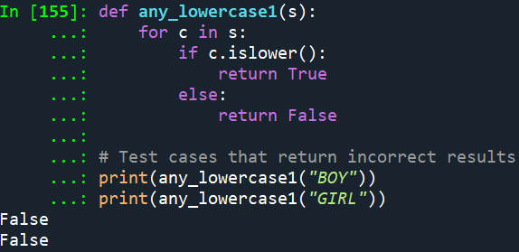 - Explanation:
The function returns `False`, which is incorrect because of considering only the first character “B” and “G” respectively, which are uppercases. The function fails to check the other characters after the first one, which could possibly be lowercase.
# Function 2:
The function “any_lowercase2(s)” will always return the string values "True" or "False", irrespective of the input because it hardly checks any of the characters of the input string `s`. This problem arises from the line `if 'c'.islower()`, where 'c' is written as a string instead of the variable `c` representing the characters in string `s`. By having 'c' as a lowercase character, the condition `if 'c'.islower()` always returns `True` without performing iteration over the characters in the input string. The code below shows a similar example that will give incorrect result:
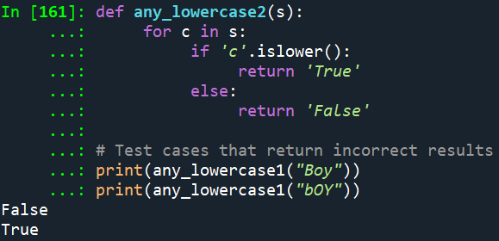
Explanation:
The function randomly returns "True" and “False”, which is incorrect irrespective of the input string. Since lowercase characters are present in “Boy” and “bOY”, it would be expected that the function should return “True” for both test cases, which did not work. This shows that the function hardly performed any character-based checks and always returns either "True" or “False” randomly. When using a for loop in Python, the loop variable (in this case, 'c') should not be put inside quotation marks.
# Function 3:
The function “any_lowercase3(s)” takes a string s as input and returns a Boolean value. The purpose of this function is to check if any character in the input string s is a lowercase letter. It does this by iterating through each character in the string and assigning the result of c.islower() to the variable flag. Finally, it returns the value of flag. Nevertheless, there is a problem with this implementation. As soon as the loop encounters the first character in s, it assigns the result of c.islower() to flag and immediately returns it. This means that the function will only check the first character of the string and ignore the rest of the characters. The code below shows a similar example that will give incorrect result:
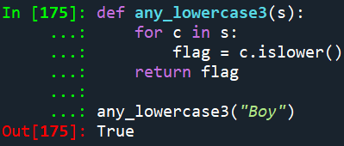
Explanation:
The function incorrectly returns `True` because it only checks the last character 'o', which is lowercase. It doesn't consider the rest of the characters in the string.
# Function 4:
The function “any_lowercase4(s)” is set to check if any character in the input string s is a lowercase letter. However, the code has a logic error in the implementation, which emanates from the way flag is being updated inside the loop. The or operator (flag = flag or c. islower()) is used in the loop to update the flag variable. This means that if flag is True (which indicates that a lowercase character has been found previously), it will not check the value of c.islower() and keep flag as True. This is incorrect because it is necessary to check each character individually and update flag accordingly. The code below shows a similar example that will give incorrect result:
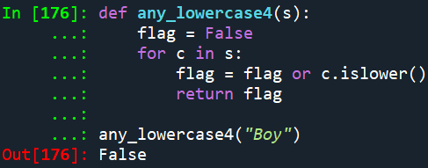
Explanation:
The function incorrectly returns `False` despite having lowercase characters in the string “Boy”. This is because the flag is False (which indicates that a no lowercase character has been found previously), and the function failed to check the value of c.islower() and maintained flag as False.
# Function 5:
In the function “any_lowercase5(s)”, the return True statement placed inside the loop will be executed after the first character is processed, regardless of whether the character is lowercase or not. The code below shows a similar example that will give incorrect result:
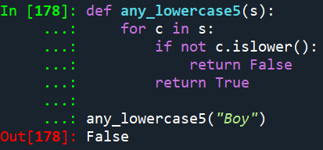
Explanation:
The function returns False immediately after processing the first character "B" because of the return False statement inside the loop. The loop ends, and the function call stops. It does not continue to check the rest of the characters in the string. This output is incorrect because the function should check if any character in the string is a lowercase letter, not just the first character.

